DRAFT - ICT Project Guidance

Documentation: Users

Version:

0.1

Author:

<name>, <role>, <group>

## Description

<TODO>

## Synopsis

Following the Four Document Model, Tutorials,HowTos, Explanation and Reference artefacts are developed for system end users.

## Contents

Description 1

Synopsis 1

Contents 2

Synopsis 3

Introduction 3

Heading Level 3 3

Heading Level 4 3

Appendices 4

Appendix A - Document Information 4

Images 4

Tables 4

References 4

Review Distribution 4

Audience 4

Structure 4

Diagrams 4

Terms 5

## Introduction

BOSSCARD/ RAID: Background [], Objective, Options, Scope[In/Out], Stakeholders [Users], Constraints, Assumptions, Risks, Dependencies, Decisions, Deliverables.

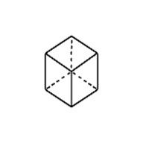  
Figure : TODO Image

### Heading Level 3

Foo

#### Heading Level 4

Bar

Table : TODO Table

|  |  |
| --- | --- |
| Foo | Bar |
| Foo | Bar |
|  |  |
|  |  |

Table : TODO Table 2

|  |  |
| --- | --- |
| Foo | Bar |
| Foo | Bar |
|  |  |
|  |  |

Four Document Model

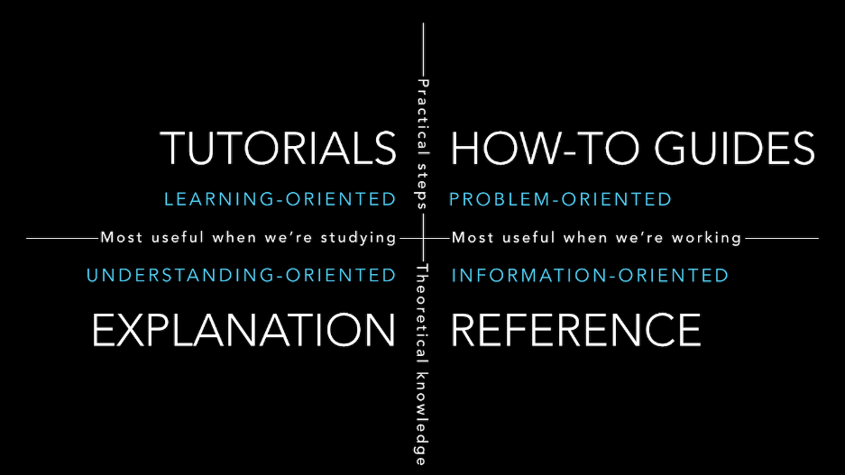

Figure : Four Document Model

Background

Background documents are learning oriented.

Tutorials

How To Guides

How To documents are problem solving oriented.

Explanation

Explanation documents are understanding oriented.  
Reference

Reference documents are information oriented.

Appendices

Appendix A - Document Information

### Versions

* 1. Initial Draft

### Images

Figure 1: TODO Image 2

### Tables

Table 1: TODO Table 3

Table 2: TODO Table 2 3

### References

**There are no sources in the current document.**

### Review Distribution

The document was distributed for review as below:

|  |  |
| --- | --- |
| Identity | Notes |
|  |  |
|  |  |
|  |  |

### Audience

The document is technical in nature, but parts are expected to be read and/or validated by a non-technical audience.

### Structure

Where possible, the document structure is guided by either ISO-* standards or best practice.

### Diagrams

Diagrams are developed for a wide audience. Unless specifically for a technical audience, where the use of industry standard diagram types (ArchiMate, UML, C4), is appropriate, diagrams are developed as simple “box & line” monochrome diagrams.

### Terms

Refer to the project’s Glossary.

##### IT

: acronym for Information, using Technology to automate and facilitate its management.

##### ICT

: acronym for Information & Communication Technology, the domain of defining Information elements and using technology to automate their communication between entities. IT is a subset of ICT.